# HAUS OF DYE

Name of store: Haus of dye

Slogan: “Wear Adire, Wear Pride”

Logo:

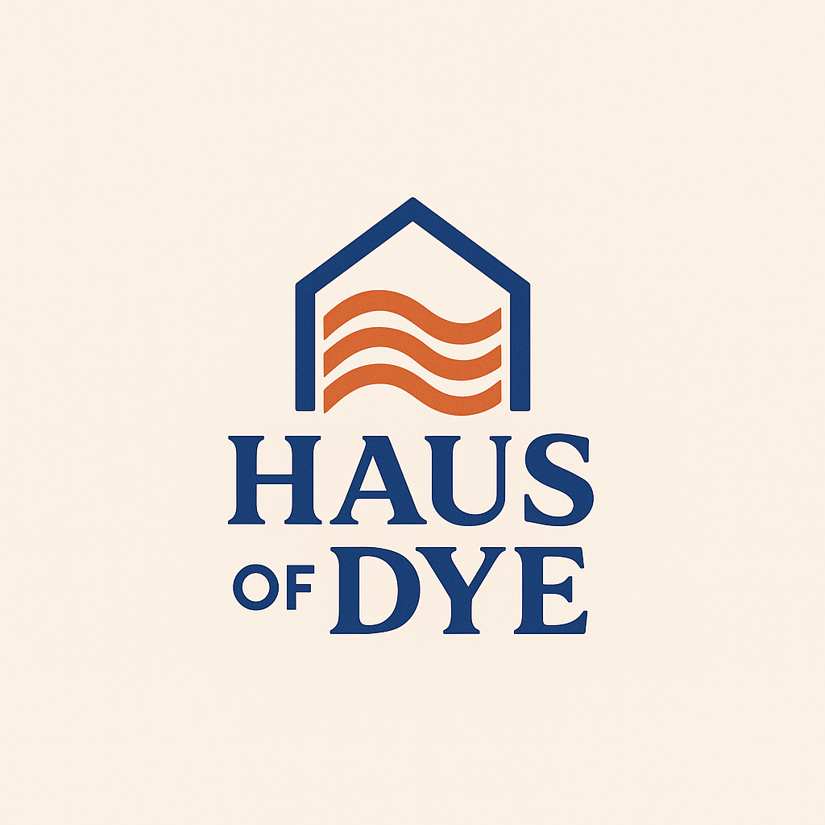

**Niche:** Focus on culturally handmade Adire fashion that blends tradition with style and sustainability.  
**USP (Unique Selling Point):** Empowering African artisans, especially women, through sustainable fashion. Each piece tells a story and supports a heritage.

**Brand Meaning:**

* **“Haus”** = Stylish, boutique, premium (“haus” is literally house in German)
* **“Dye”** = Represents Adire, colour, creativity
* Together, **Haus of Dye** = A stylish home for colourful cultural fashion

Colour Theme of Haus of Dye:

1. **Royal Blue** – #3F51B5  
   ▸ Used for navbar background, buttons, and primary branding  
   ▸ Represents calm, elegance, and African richness
2. **Off-White / Creamy Beige** – #FDF6ED  
   ▸ Used as the page background  
   ▸ Gives a natural, clean, fabric-inspired feel
3. **Warm Orange** – #D96C3B  
   ▸ Used for login button, accent colours, hover effects  
   ▸ Adds energy, vibrancy, and modern contrast

**About Us (Haus of Dye)**

Welcome to **Haus of Dye** where tradition meets trend, and heritage is worn with pride.

At Haus of Dye, we are more than just an Adire fashion store. We are a **creative movement**, a **cultural home**, and a **platform for preserving African textile art** through modern design. Inspired by the age-old Yoruba technique of fabric dyeing, we blend deep-rooted traditions with contemporary fashion to create clothing that tells a story a story of identity, colour, and cultural beauty.

**Our Vision**

To become a leading digital house for Adire fabrics, showcasing authentic African design to the world while empowering local craftsmanship and telling timeless cultural stories through fashion.

**Our Mission**

* To **promote Adire** as a valuable piece of African heritage.
* To **connect local artisans** and their handmade products to the global digital marketplace.
* To offer **stylish, sustainable, and meaningful** textile pieces for fashion-forward individuals.
* To create a platform that reflects **African excellence**, innovation, and authenticity.

**What Makes Us Different**

* Every design in our collection carries **the fingerprint of tradition** crafted using ancient resist-dyeing techniques and modern fashion elements.
* We **source directly** from indigenous dye artists, ensuring fair trade, quality, and originality.
* Our digital store is built for ease, offering a seamless and interactive shopping experience for our customers.
* We are **youth-led, passion-driven**, and committed to creating value in every piece we sell.

**Our Cultural Promise**

Adire is more than fabric; it is **art, language, history, and pride** woven and dyed into wearable beauty. At Haus of Dye, we believe in *wearing culture loud*, in expressing our African roots without compromise, and in preserving craftsmanship in an increasingly automated world.

**Our Story**

Born out of a university group project, Haus of Dye began as an idea to **digitally showcase Nigerian fabrics** to a global audience. What started as a classroom initiative has grown into a meaningful brand project driven by teamwork, creativity, and a strong connection to cultural roots.

Today, our team works across design, digital tech, and content creation to deliver an online store that’s stylish, authentic, and proudly African.

**Join the Movement**

Whether you're here to shop, support, or simply explore you're welcome in the **Haus of Dye** family.

*Wear Adire, Wear Pride.*